ARTIST’S IDEA STATEMENT
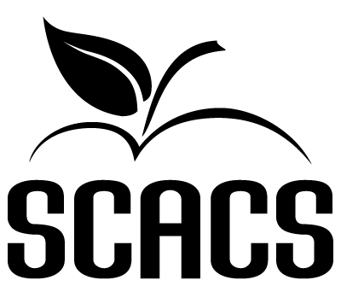
(please print or type)

Name |  |  |  |  |  | School #
Category |  |  |  | Medium
Title of Entry

1. | How or why did you choose your subject? Where did you get the idea? List any website used as a source material.
2. | The following question applies to all categories except photography categories and digital media.
 | Did you use a photograph as a source?
 |  |  | Yes – personal photograph (taken by artist)*
 |  |  | Yes – non-personal photograph (taken by someone else)*
 |  |  | No
 | *If you marked either yes above, you must submit to the judges a copy of the photograph with this Artist’s Idea Statement. Please have your name on the back of the photo.
3. | Explain the process you used in making your entry. How was your idea developed? Be specific! If printmaking, what type of ink did you use (water-based, oil, etc.); what matrix did you use (wood, linoleum, etc.)?
4. | How long did it take to do this artwork? On what date was it completed?
5. | What help did you receive from other people (friends, parents, teachers):
 | in planning the piece?
 | while working on the piece?
 | in framing or other ways of presenting it?
STATEMENT OF ORIGINALITY
I certify that this project is my own original and authentic work and that I received no help in
completing this project other than general instructions and supervision.

Student’s Name |  | Date

This idea statement is to be attached to one of the two judging forms accompanying the artwork. Three points will be deducted if it is missing or incomplete. Use the back of this sheet if you need more space. Type if possible.

