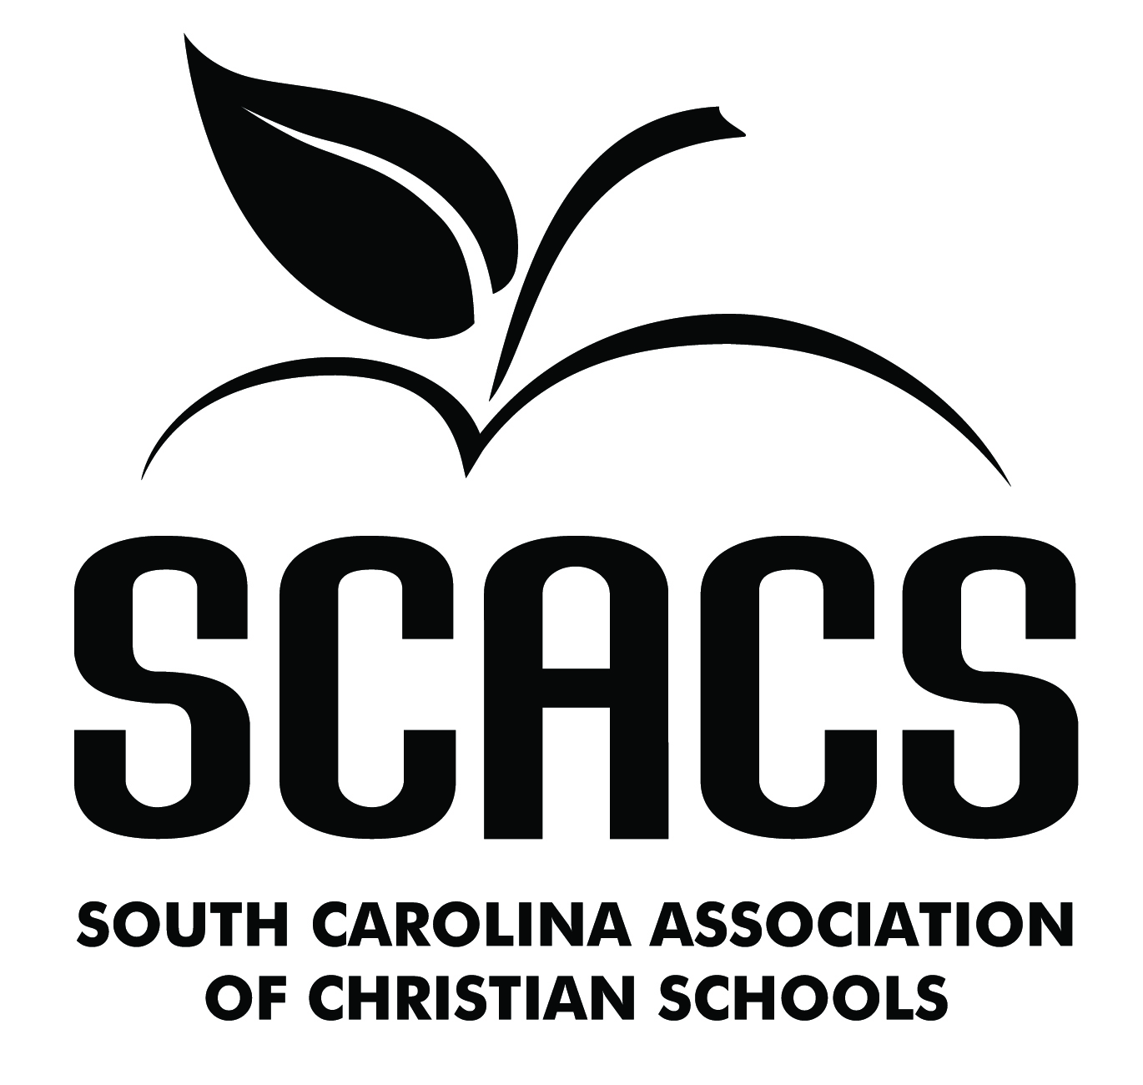 | ART  Elementary

Calligraphy 161 261 Acrylic Painting 166 266
Crafts 162 262 Printmaking 169 269
Monochromatic Drawing 163 263 Sculpture 170 270
Polychromatic Drawing 164 264 Textiles 171 271
Oil Painting 165 265 Watercolors 172 272
Mixed Media 173 273

Name: |  |  | School #
Identification/Title: |  |  | Grade

FACTORS EVALUATED | COMMENTS | POINTS (4-10)
TECHNIQUE
- Is the medium used appropriate?
- Is skillfulness displayed?
- Is there consistency?
ORIGINALITY
- Does this work possess creativity?
- Does this work possess individuality?
- Does this work show imagination?
COMPOSITION
- Is there harmony of composition?
- Is there visual balance?
- Is there form and color coordination?
COMMUNICATION
- Does this work reflect both knowledge of and experience with the subject?
- Does this work portray or convey a message?
- Does this work repeatedly stimulate or satisfy?
 | TOTAL POINTS (40 possible)

POINT SCALE
9-10 Superior | 36-40 Superior
8 Excellent | 32-35 Excellent
7 Good | 28-31 Good
6 Fair | 24-27 Fair
5 Poor | 0-23 Poor | Judge’s Signature

