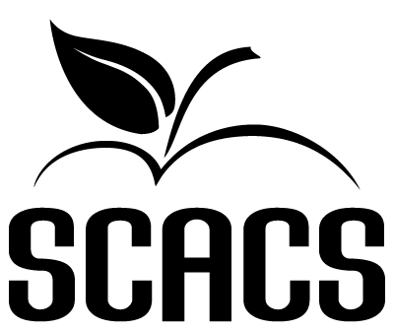 | GARMENT CONSTRUCTION  Secondary  Only Level IV 477

Name: |  |  | School #
Identification/Title: |  |  | Grade

FACTORS EVALUATED | COMMENTS | POINTS  (6-20)
TECHNIQUE:
1. Was appropriate fabric chosen?
2. Is skillful construction displayed?
3. Is construction consistent?

ORIGINALITY:

1. Does this work possess creativity?

2. Does this work possess individuality?

3. Does this work show imagination?

EFFECTIVENESS:

1. Is there harmony of composition?

2. Is there visual balance?
3. Is there form and color coordination?
4. Communication:
(a) Does this work portray or convey a message?
(b) Does this work repeatedly stimulate or satisfy?
DIFFICULTY:
1. Does the garment display knowledge and experience with the construction techniques?
2. Does the garment display appropriate detail work?

POINT SCALE
18-20 Superior | 72-80 Superior | Total (80 possible points)
16-17 Excellent | 64-71 Excellent
14-15 Good | 56-63 Good
12-13 Fair | 48-55 Fair
6-11 Poor | 0-47 Poor | Judge’s Signature

