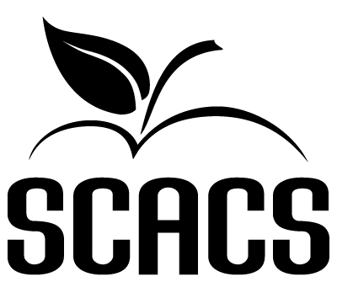 | ART  Secondary

Calligraphy 361 461 Printmaking 369 469
Crafts 362 462 Sculpture 370 470
Monochromatic Drawing 363 463 Textiles 371 471
Polychromatic Drawing 364 464 Watercolors 372 472
Oil Painting 365 465 Mixed Media 373 473
Acrylic Painting 366 466

Name: |  |  | School #
Identification/Title: |  |  | Grade

FACTORS EVALUATED | COMMENTS | POINTS  (6-20)
TECHNIQUE:
1. Is the medium used appropriate?
2. Is skillfulness displayed?
3. Is there consistency?

ORIGINALITY:

1. Does this work possess creativity?

2. Does this work possess individuality?

3. Does this work show imagination?

COMPOSITION:

1. Is there harmony of composition?

2. Is there visual balance?

3. Is there form and color coordination?

COMMUNICATION:

1. Does this work reflect both knowledge of and experience with the subject?
2. Does this work portray or convey a message?
3. Does this work repeatedly stimulate or satisfy?

POINT SCALE
18-20 Superior | 72-80 Superior | Total (80 possible points)
16-17 Excellent | 64-71 Excellent
14-15 Good | 56-63 Good
12-13 Fair | 48-55 Fair
6-11 Poor | 0-47 Poor | Judge’s Signature

