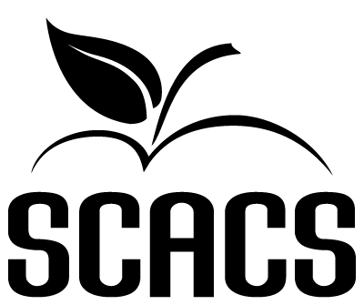 | SCIENCE FAIR  Secondary

Biological Science Project 397 497
Physical Science Project 398 498

Name: |  |  | School #
Title: |  |  | Grade

FACTORS EVALUATED | COMMENTS | POINTS
CREATIVITY and SCIENTIFIC THOUGHT  1. Is the project unique? Is the approach practical, and is the apparatus and/or testing method appropriate?  2. Is the procedure well thought through, and is the hypothesis testable?  3. Is the project realistic and the solution beneficial?  (20 points possible) |  | (20 pts.)
RESEARCH and EXPERIMENTATION  1. Did the student conduct enough background research to be qualified to conduct the experiment?  2. Was sufficient data collected? Does the data appear to be accurate and realistic?  3. Was the experiment controlled, repeated, and/or did it contain sufficient population to yield accurate results?  (30 points possible) |  | (30 pts.)
PRESENTATION and DOCUMENTATION  1. Does the Log Book contain sufficient information in order to reconstruct the project?  2. Does the presentation of material and/or student interview reflect a well-balanced knowledge of the project?  3. Does the research paper meet all requirements? Are all required and applicable forms complete?  (25 points possible) |  | (25 pts.)
THOROUGHNESS and TECHNICAL SKILL  1. Are all areas of the project thoroughly covered and discussed?  2. Is the apparatus or testing procedure well-constructed, and did the student do his own work?  3. Does the student have recommendations as to further or alternate methods to do additional projects based on the results?  (15 points possible) |  | (15 pts.)
CLARITY and DRAMATIC VALUE  1. Is the presentation clear and easy to follow? Are the conclusions and findings appropriately presented?  2. Is the presentation professional in appearance and appropriate for the project?  3. Is the information correctly presented, and is data presented in a correct, easy-to-follow manner?  (10 points possible) |  | (10 pts.)

 |  | Total (100 possible points)
STATEMENT OF ORIGINALITY | POINT SCALE
I certify that this project is my own | 90-100 Superior
original and authentic work and that I | 80-89 Excellent | Student’s Signature
received no help in completing this | 70-79 Good
project other than general instruction | 60-69 Fair
and supervision. | 0-59 Poor | Judge’s Signature

