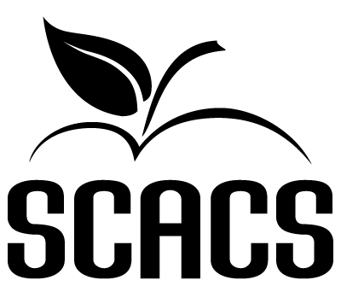 | SPEECH  Secondary
Original Persuasive Oratory 349 449

Name: |  |  | Grade: |  | School #
Selection

FACTORS EVALUATED | COMMENTS | POINTS  (4-10)
MEMORIZATION: “the largely memorized oral presentation...” (see AACS manual)
1. Knowledge of material
2. Hesitation or confusion
3. Necessity for prompting

SELECTION:

1. Originality: (a) positive approach (b) use of imagination (c) individualistic approach (d) human interest appeal

2. Content: (a) relates to subject (b) logical development of ideas (c) clarity of ideas (d) tasteful (e) meets category

DICTION: 1. Fluency/Articulation

2. Pronunciation 3. Enunciation 4. Voice projection 5. General pitch 6. Quality of voice
COMMUNICATION: 1. Mental rapport with audience 2. Eye contact 3. Ability to hold attention

USE OF BODY: 1. Posture 2. Bodily movement 3. Gestures 4. Facial expressions 5. Stage presence 6. Distracting mannerism

INTERPRETATION: 1. Style 2. Proper emphasis 3. Phrasing 4. Contrast

5. Expressiveness 6. Creation of mood

7. Sincerity of tone

OVERALL EFFECTIVENESS:

1. Proficiency of delivery 2. Personal appearance 3. Poise 4. Organization of thought

POINT SCALE
9-10 Superior | 63-70 Superior | Total (70 possible points)
8 Excellent | 56-62 Excellent
7 Good | 49-55 Good
6 Fair | 42-48 Fair
5 Poor | 0-41 Poor | Judge’s Signature

