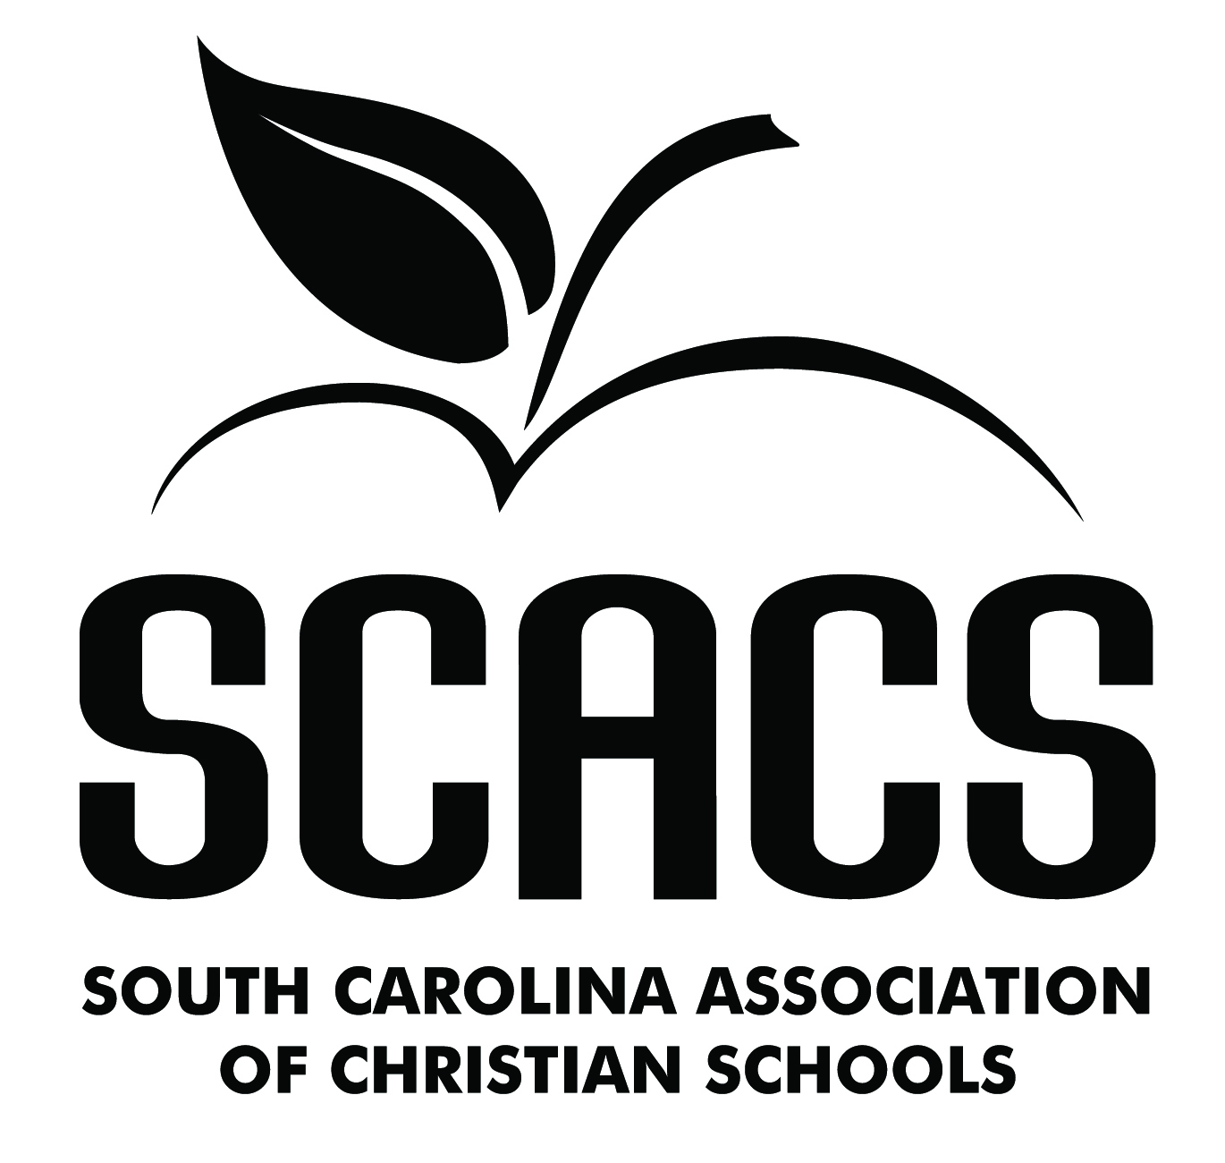 | ART  Elementary

Calligraphy 261 Acrylic Painting 266
Crafts 262 Printmaking 269
Monochromatic Drawing 263 Sculpture 270
Polychromatic Drawing 264 Textiles 271
Oil Painting 265 Watercolors 272
Mixed Media 273

Name: |  |  | School #
Identification/Title: |  |  | Grade

FACTORS EVALUATED | COMMENTS | POINTS (4-10)
TECHNIQUE
- Is the medium used appropriate?
- Is skillfulness displayed?
- Is there consistency?
ORIGINALITY
- Does this work possess creativity?
- Does this work possess individuality?
- Does this work show imagination?
COMPOSITION
- Is there harmony of composition?
- Is there visual balance?
- Is there form and color coordination?
COMMUNICATION
- Does this work reflect both knowledge of and experience with the subject?
- Does this work portray or convey a message?
- Does this work repeatedly stimulate or satisfy?
 | TOTAL POINTS (40 possible)

POINT SCALE
9-10 Superior | 36-40 Superior
8 Excellent | 32-35 Excellent
7 Good | 28-31 Good
6 Fair | 24-27 Fair
5 Poor | 0-23 Poor | Judge’s Signature

